Consulting Day in the Life: What MBB Analysts Actually Do
Meta description: A consulting day in the life at McKinsey, BCG and Bain: what a study is, the Monday to Friday schedule, how the week splits, and how AI tools changed it in 2026.

A consulting day in the life at McKinsey, BCG or Bain is one slice of one client project: interviews and Excel during the day, slides at night, and a client meeting at the end of the week. Hacking the Case Interview's June 2026 estimate puts a junior consultant's week at about 28 percent data analysis, 22 percent building slides and 15 percent client meetings and interviews, with the rest going to team sessions, reading and travel [VERIFY: Hacking the Case Interview, June 2026]. Most teams now spend two or three days a week at the client site and Friday in the home office [VERIFY: StrategyCase, July 2026]. In this article, I lay out what a study is, what Monday through Friday look like hour by hour, how the week splits, how AI tools changed the work in 2026, and what the intern version looks like.

What does a McKinsey Business Analyst do all day?
A McKinsey Business Analyst owns one workstream on a client project and spends the day interviewing client staff, analyzing the client's data in Excel and turning what comes out into slides. A workstream is one piece of the client's question that can be answered on its own. McKinsey's 2026 Business Analyst posting says you'll "take ownership of a workstream" and get there by combining "research, analyzing data, interviews, and brainstorming," and it asks for the ability to travel to and work in places like "factories, hospitals, mines" [VERIFY: mckinsey.com Business Analyst posting, 2026 wording]. The team around you is small, usually three to six people on one client problem, with a partner above and an engagement manager running the day to day [VERIFY: Hacking the Case Interview, June 2026]. A Business Analyst's day splits between finding out what's true at the client and turning it into pages a senior executive will act on.

Is a BCG Associate's day different from a McKinsey Business Analyst's?
No, not in a way you'd notice in your first year. The main difference is the job title. BCG calls its undergraduate hires Associates and its summer interns Summer Associates, and Bain calls them Associate Consultants and Associate Consultant Interns [VERIFY: careers.bcg.com entry-level roles page and bain.com ACI page, October 2026]. Bain's intern page describes the same job in its own words: you'll "own a distinct piece of that project," the role "requires regular travel," and you should "expect to be in-person with your team most days" [VERIFY: bain.com ACI page, October 2026]. The shape is identical at all three: a small case team, a manager, a partner, and a client question with a deadline. McKinsey, BCG and Bain run the same analyst day under three different job titles, and the differences you'll feel are between teams, not between firms.

1. A study is one client question split into workstreams
A study is McKinsey's word for a project. BCG and Bain say case.

A client brings the firm a question. Should we enter this market. Why are our costs 20 percent higher than our closest competitor's. Which of these four divisions should we sell. The firm puts a team on it, usually for two to six months [VERIFY: Hacking the Case Interview, June 2026, on study length].

The team has three layers. A partner owns the client relationship, sold the work, and shows up half a day to a day a week to check the answer. An engagement manager (a project leader at BCG, a manager at Bain) runs the team every day: sets the plan, reviews every page, and makes the call at 10 p.m. when something has to give. Below them sit two to four consultants and analysts who do the work. Hacking the Case Interview puts the whole group at three to six people on a single engagement [VERIFY: Hacking the Case Interview, June 2026]. Bigger studies stack more of each layer.

The engagement manager breaks the question into workstreams. On a cost study, one person owns procurement, another owns manufacturing, a third owns overhead. Each workstream has its own interviews, its own data and its own pages in the final deck. As the analyst, you own one of them. The engagement manager checks your work daily and the partner checks it weekly, but the interviews, the analysis and the first draft of every page in your section come from you.

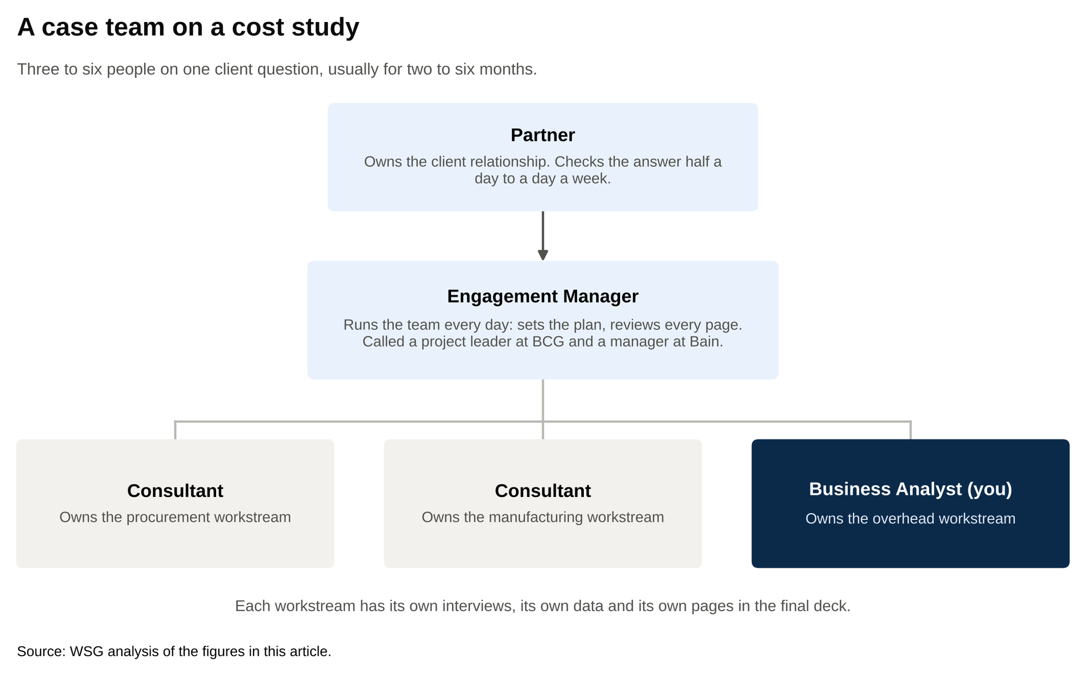
The partner checks the answer weekly, the engagement manager runs the team daily, and each consultant owns one workstream.
Source: WSG analysis of the figures in this article.

The team works hypothesis first. Instead of collecting everything and seeing what it says, you write down on day one what you think the answer is, then spend the study trying to prove or disprove it. Say the question is why manufacturing costs are high. Your day-one hypothesis might be that one plant drags the average up because it runs too much overtime. Every interview you book and every data request you send now has a purpose: does the overtime story hold? If the plant manager tells you overtime is normal but scrap rates doubled last year, the hypothesis changes, and so does next week's plan. A study is one question broken into workstreams, and a Business Analyst's job is to own one of them from the first hypothesis to the final page.

2. Monday is travel and the plan for the week
On a travel study, Monday starts at 5 a.m. A former McKinsey consultant who wrote up his week for Leland in February 2026 puts the morning routine at 5:00 to 5:45, transit and email at 5:45 to 6:45, and the airport and flight at 6:45 to 8:15, with the team on site by about 1 p.m. after the drive from the airport and lunch [VERIFY: Leland, February 2026]. The first working hour of the week happens at the gate: what the partner wants by Wednesday, what the client sent overnight, what the engagement manager rearranged.

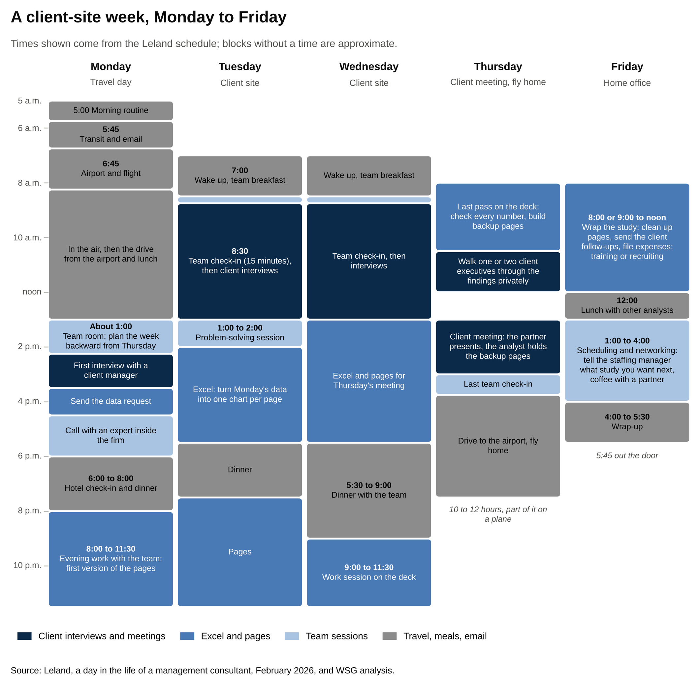
Monday starts at 5 a.m. with a flight, the client-site evenings run to 11:30 p.m., and Friday ends by 5:45.
Source: Leland, a day in the life of a management consultant, February 2026, and WSG analysis.

How many days you're on the road depends on the client. StrategyCase's July 2026 read is that most teams now travel two to three days a week and that "your travel load in 2026 is decided by your client, not by a firm policy" [VERIFY: StrategyCase, July 2026].
On the ground, Monday is about the plan. The team meets in the team room, which is a conference room the client lends the firm for the length of the study. The engagement manager lays out the week backward from Thursday's client meeting: which pages have to exist by then, who owns each one, and which interviews and data requests have to happen first for those pages to be possible. That plan is the week's to-do list. For an analyst, it typically holds three interviews, a couple of data pulls and four or five pages.

Monday afternoon is the start of the real work, and it has three usual pieces.

- A first interview with a client manager whose numbers you've been staring at since last week.
- A data request to the client's finance or operations team. The wording matters more than it sounds. A request that says "send me plant costs" comes back a week later as one total. A request that says "monthly cost by plant, split into labor, materials and overhead, January 2024 through June 2026, in Excel" comes back in a form you can use.
- A call with an expert inside the firm, usually a consultant somewhere else in the world who did a similar study and has twenty minutes to tell you what you're about to get wrong. McKinsey's internal AI tool, Lilli, and Bain's equivalent, Sage, now do the first pass of this search across the firm's past work, and the human call is where you ask the question the documents don't answer [VERIFY: Bain careers blog, August 2025, on Sage].

The evening is at the hotel. The Leland schedule puts check-in and dinner at 6 to 8 p.m. and evening work at 8 to 11:30 p.m., usually with the team in a meeting room building the first version of the pages [VERIFY: Leland, February 2026].

Monday sets the plan, and everything the team does through Thursday is that plan being carried out.

3. Tuesday and Wednesday are interviews by day and pages by night
Tuesday starts later than Monday. The Leland schedule has a 7 a.m. wake-up, team breakfast, and a client check-in at 8:30 [VERIFY: Leland, February 2026]. Hacking the Case Interview's non-travel day has the same 8:30 team check-in [VERIFY: Hacking the Case Interview, June 2026]. The check-in is fifteen minutes. The engagement manager goes around the table and each person says what they finished, what they're stuck on, and what they need from someone else.

Then the day splits into two kinds of work.

The first kind is finding things out. Interviews with client staff are the center of the job at the analyst level. A plant manager, a regional sales lead, a finance director. You walk in with your hypothesis and eight questions, and you walk out with three facts that matter and the name of someone else to talk to. McKinsey's posting language about "factories, hospitals, mines" describes real days. A summer Business Analyst writing on McKinsey's careers blog described traveling internationally to interview coaches and players for a major US sports team client [VERIFY: mckinsey.com careers blog, September 2020]. Interviews are where the study learns what the spreadsheet can't tell it.

The second kind is analysis. Monday's data request comes back, and the afternoon goes into Excel turning it into an answer: cost per unit by plant, or margin by customer, or headcount by function, with one chart at the end that says one thing. The chart goes onto a page, and the page gets a title that states the finding in a full sentence. McKinsey people call this the so-what. Management Consulted calls it a standalone sentence title [VERIFY: Management Consulted slide deck guide]. "Plant costs by region" is a label. "The Midwest plant costs 22 percent more per unit than the other three, and overtime explains most of the gap" is a so-what. If the title doesn't state a finding, the page isn't done.

Early afternoon on one of these days brings the problem-solving session. That's a meeting where the whole team sits down with the pages so far and argues about the answer, usually with the partner in the room, or an associate partner, the rank just below partner. The Leland schedule puts it at 1 to 2 p.m. with the associate partner. Hacking the Case Interview's sample day puts it at 11 a.m. with the engagement manager and partner [VERIFY: Leland, February 2026; Hacking the Case Interview, June 2026]. This is where an analyst's work gets tested. The partner asks why the Midwest plant's overtime is high, and you either know from Tuesday's interview or you don't, and if you don't, that's Wednesday's interview. In the problem-solving session, the partner questions every page, and any question you can't answer becomes your next interview or data request.

Between sessions, the deck gets built the way the firms build decks, and three ideas run through all of it.

The first is the ghost deck. Early in the study, the engagement manager writes the page titles for the whole presentation, in order, with the pages themselves mostly empty, so the team can see the argument before any analysis exists. Management Consulted describes it as a barebones outline built "before filling in the analysis," so the team only builds the slides it will present [VERIFY: Management Consulted slide deck guide]. Your workstream shows up as four or five empty titles, and your job for the next three weeks is to make them true or replace them.

The second is the pyramid principle, from Barbara Minto's book of the same name. The answer goes first, then the two or three reasons that support it, then the evidence under each reason. On a page, the title is the answer and the chart is the evidence. Take the plant example. The title says the Midwest plant costs 22 percent more per unit and overtime explains most of the gap. The two reasons underneath are higher overtime hours per unit and a jump in scrap. Under each reason sits what proves it: the monthly cost data by plant and the notes from the plant manager interview. In a deck, the same shape runs across all the pages. The executive summary on page two gives the client the whole answer, and the forty pages behind it hold the evidence for anyone who wants to check.

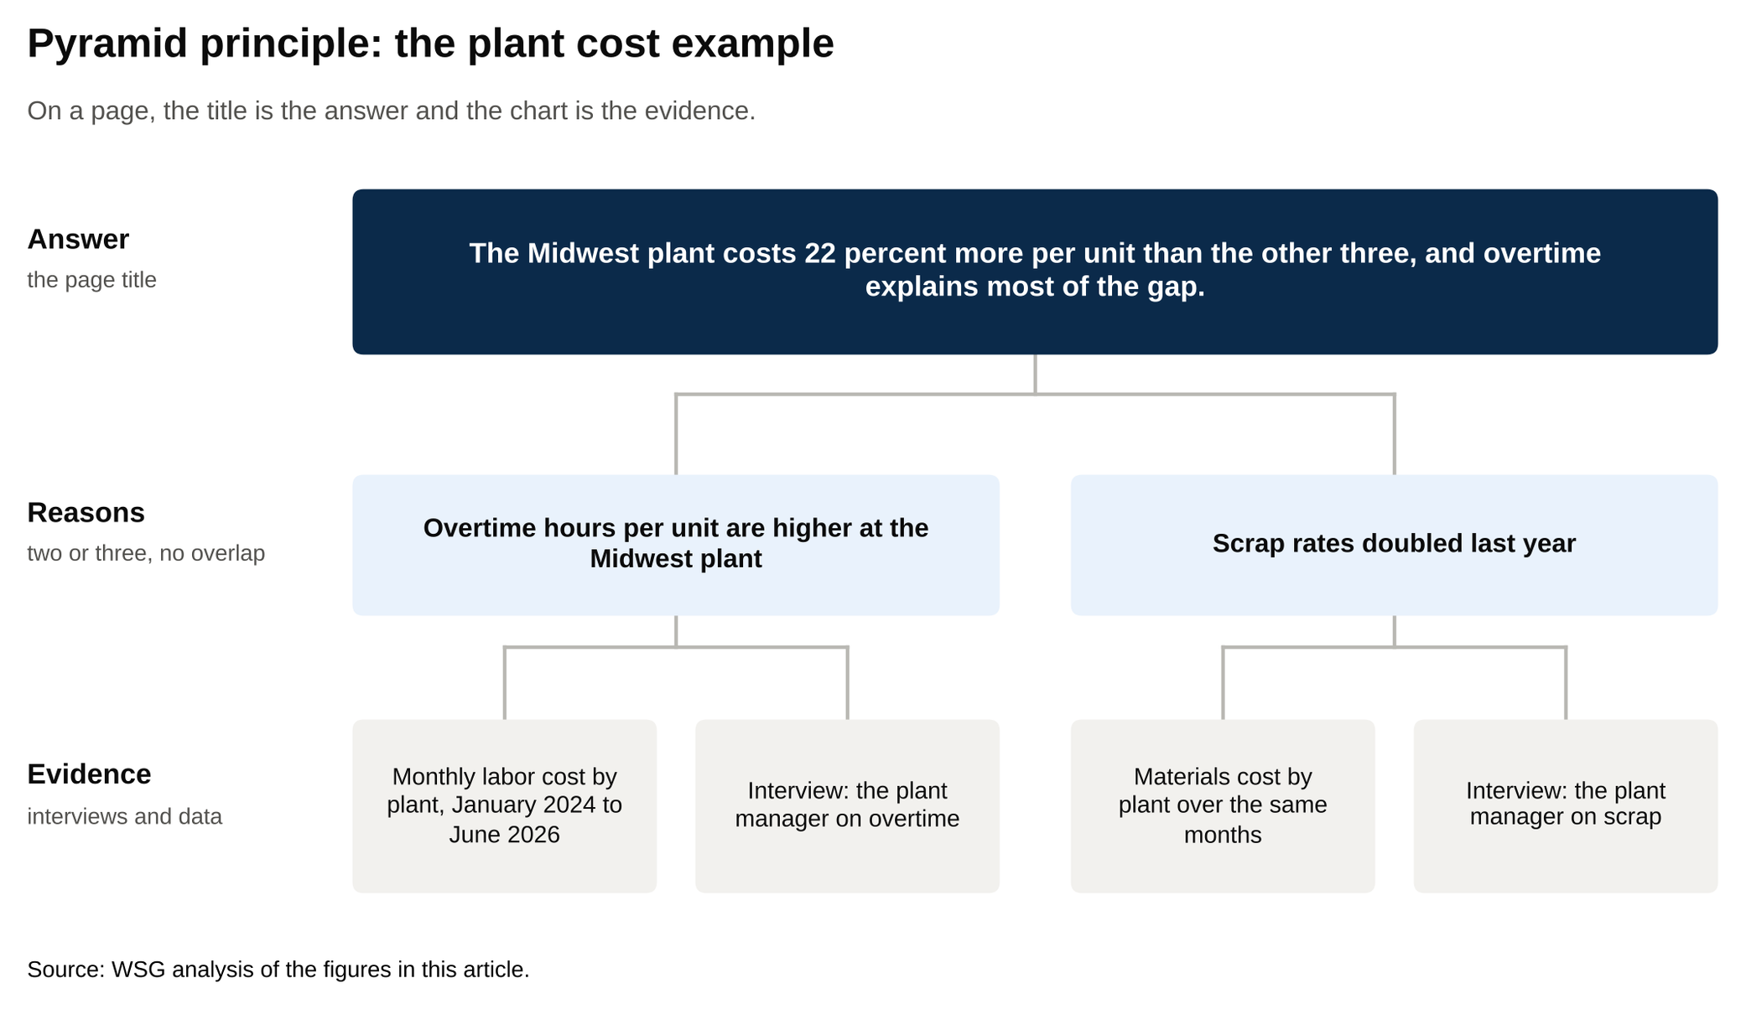
The answer is the page title, the reasons sit under it, and the evidence sits under each reason.
Source: WSG analysis of the figures in this article.

The third is MECE, pronounced "mee-see," which stands for mutually exclusive and collectively exhaustive. The reasons under an answer don't overlap, and together they leave nothing out. If your three reasons for high plant costs are overtime, scrap and "labor," the list fails, because overtime is labor. An analyst spends two years being told a page isn't MECE until it becomes a reflex.

Wednesday looks like Tuesday with the pressure turned up, because Thursday is coming.

The Leland schedule has dinner with the team from 5:30 to 9 p.m. and a work session from 9 to 11:30 p.m. [VERIFY: Leland, February 2026]. Tuesday and Wednesday are interviews and Excel in the daytime and pages at night, with a problem-solving session in the middle where the partner tests whether any of it holds.

4. Thursday is the client meeting, or the run-up to it
Every study runs on a rhythm of client meetings, and the biggest ones are steering committee meetings, which consultants shorten to SteerCo. A steering committee is the group of senior client executives who oversee the study, usually the CEO or a division head plus the CFO and the executives whose areas the work touches. They review the pages and decide whether to act on them. How often they meet depends on the client. StrategyCase lists a weekly client steering committee as one of the two recurring meetings that shape a consultant's week, and on other studies it's one every three or four weeks plus a final one at the end [VERIFY: StrategyCase, July 2026]. On a twelve-week study with the second rhythm, that's a steering committee in weeks four, eight and twelve, with a smaller client meeting on the Thursdays in between.

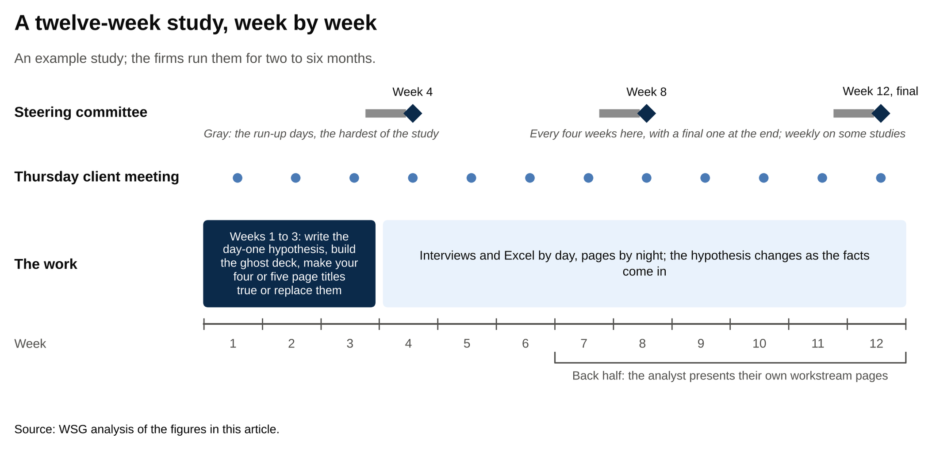
Steering committees fall every three or four weeks, with a final one in week twelve.
Source: WSG analysis of the figures in this article.

The days before a SteerCo are the hardest days of the study.

On a SteerCo week, Thursday morning is the last pass on the deck: every number checked twice, every source footnoted, and backup pages built for every question the partner thinks the CFO might ask. A backup page is a slide that lives in the appendix with the detail behind a headline number, so when the operations executive asks for the plant-by-plant view, it's page 47 instead of "we'll get back to you."

Then comes the pre-wire. A pre-wire is a short one-on-one meeting with one or two of the client executives before the main session, where the partner or engagement manager walks them through the findings privately, so an executive whose area is being criticized sees the numbers first. For the analyst, that moves the deadline: if your overtime page goes into a pre-wire, its numbers have to be final before that meeting, which can be a day ahead of the main one.

In the meeting itself, the partner presents and the engagement manager handles the detail. The analyst sits with the backup pages, ready to hand over the plant-by-plant numbers when they're asked for. That changes over a study. An older version of McKinsey's Business Analyst posting said BAs "present results to client management," and the firm's current undergraduate page describes the role as "analyzing data, presenting ideas, and shaping recommendations" [VERIFY: exact quote on mckinsey.com undergraduate candidates page; page unreachable in October 11 QA, confirm before publish. Older posting language confirmed on a job-board mirror of the posting that closed August 2024]. By the back half of a study, it's common for the analyst to present the pages from their own workstream, with the engagement manager fielding the follow-ups.

On a normal Thursday, the meeting is smaller: a progress review with the client's project lead, a last team check-in, and then the airport. The Leland schedule says the Thursday timetable "shifts slightly to accommodate the drive back to the airport" [VERIFY: Leland, February 2026]. Ten to twelve hours, part of it on a plane. Thursday is the client meeting, where senior executives decide whether to act on the pages the team built Monday through Wednesday.

5. Friday is the office day that decides your next study
Friday is in the home office, and it's the shortest day of the week.

The Leland schedule runs 8 to 9 a.m. start, work until noon, lunch, scheduling and networking from 1 to 4 p.m., wrap-up to 5:30, and out the door by 5:45 [VERIFY: Leland, February 2026]. StrategyCase describes the same shape: Fridays shorter and usually at a home office [VERIFY: StrategyCase, July 2026].

Some of the day is wrapping the study: cleaning up pages that were rushed on Wednesday night, sending the client the follow-ups promised in Thursday's meeting, filing expenses. Some of it is training, which the firms run in blocks over the first two years. Some of it is recruiting, sitting across from candidates whose resumes look like yours did two years ago.

The rest is talking to people about staffing. Consultants don't have a permanent boss. Each time a study ends, a staffing manager, whose title varies by firm and office, matches you to the next one, weighing what the firm needs, what you've asked for, and what the engagement managers who've worked with you said in your reviews. Friday is when you tell that person what kind of study you want next, and when you have coffee with a partner you worked with who might put your name forward. Lunch with the other analysts is how you learn which engagement managers to hope for and which studies are running late nights. Friday is the short day, and it's the day that decides which study you're on next.

6. Excel is about a quarter of the week and slides about a fifth
Add the days up and the shape is clearer than any single day. Hacking the Case Interview's June 2026 table for a junior consultant's week looks like this [VERIFY: Hacking the Case Interview, June 2026; presented as an estimate, not survey data]:

Activity | Share of the week | Hours in a 65-hour week
Data analysis and Excel modeling | 28 percent | About 18
Building pages | 22 percent | About 14
Client meetings and interviews | 15 percent | About 10
Internal team syncs and problem-solving sessions | 12 percent | About 8
Research and reading | 11 percent | About 7
Travel, email and admin | 12 percent | About 8

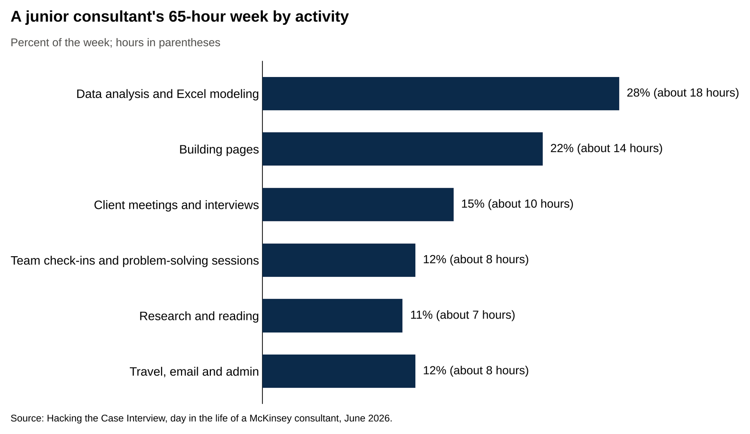
Excel takes 28 percent of the week, pages 22 percent, and client meetings and interviews 15 percent.
Source: Hacking the Case Interview, day in the life of a McKinsey consultant, June 2026.

Two things in that table matter for a student deciding whether to recruit.

The first is the ratio of talking to modeling. Client meetings, interviews and internal sessions add up to about 27 percent of the week, which is as much time as Excel gets. The same person does both: you run the interview with the plant manager, then build the model from what you heard, then defend the number in the problem-solving session. A student who loves quiet analytical work and dislikes asking strangers hard questions will find the job harder than expected. A student who likes both will find it fits.

The second is how little of the week is "strategy" in the sense the word suggests. There's no hour on the calendar for sitting and thinking big thoughts. The strategy comes out of the pages, the pages come out of the interviews and the data, and the analyst is the person doing both. Hacking the Case Interview puts Business Analyst hours at 55 to 65 a week on a study, and StrategyCase's July 2026 range for a normal McKinsey week is 55 to 70 [VERIFY: Hacking the Case Interview, June 2026; StrategyCase, July 2026]. Between studies, consultants are "on the beach," the firms' term for unstaffed time, and the week drops into the 40s [VERIFY: Hacking the Case Interview, June 2026]. A Business Analyst's week is about a quarter Excel, a fifth slides and a quarter talking to people, and the strategy is what those add up to rather than a separate activity.

7. In 2026, AI tools draft the first cut and analysts judge it
The biggest change to the analyst's day since 2023 is the AI tool each firm has built on top of its own past work.

At McKinsey the tool is Lilli. It searches more than 100,000 internal documents and interviews, and Business Insider reported in April 2025 that over 70 percent of the firm's employees used it, about 17 times a week each [VERIFY: Business Insider, April 2025]. It now shows up in recruiting too. In January 2026 Fortune reported that some final-round candidates are asked to work with Lilli during the interview [VERIFY: Fortune, January 14, 2026].

At BCG, the slide tool Deckster has a "review this" button that grades a junior consultant's slide, and about 40 percent of associates used it weekly in spring 2025 [VERIFY: Business Insider, April 2025]. Bain gives every employee ChatGPT Enterprise, runs an in-house platform called Sage for finding case insights and summarizing research, and now writes into its intern posting that the role "requires the regular use of generative AI tools" [VERIFY: bain.com careers blog, August 2025; bain.com ACI page, October 2026].

What this does to the week is compress two of the tasks above: the expert search in section 2 and the first cut of a page in section 3. The research on what the firm already knows about an industry, the first draft of a synthesis, and the first version of a slide all come faster, so the research row in the table shrinks and a draft page exists before lunch. What it doesn't compress is the part that was always the job. The interview where the plant manager tells you the overtime number is wrong. The problem-solving session where the partner takes the argument apart. The judgment about which finding goes on page one. If anything, those take up a bigger share of the week, because the tool can draft a page but can't tell you whether it's true. The 2026 analyst spends less of the day building pages from scratch and more of it deciding what the pages should say, and the interviews and problem-solving sessions haven't changed at all.

8. Interns do the same job in eight to ten weeks
The summer version is the same job on a shorter clock.

McKinsey's Business Analyst Intern posting says interns join a client service team for 8 to 10 weeks. BCG's entry-level page puts the Summer Associate program at about 8 to 12 weeks between June and August. Bain's Associate Consultant Intern page says the summer "begins with one week of training after which point you'll be staffed on a real case team," with the length varying by office [VERIFY: mckinsey.com Business Analyst Intern posting, careers.bcg.com entry-level roles page and bain.com ACI page, October 2026].

An intern gets one workstream, smaller than a full-time analyst's, and the same rhythm: interviews, data, pages, problem-solving sessions, and the Thursday meeting. The sports team interviews in section 3 came from a summer Business Analyst's write-up on McKinsey's careers blog, so the travel and the client contact are part of the intern version too [VERIFY: mckinsey.com careers blog, September 2020]. Bain's page says the summer "may lead to invitation for interviews or even an offer to join us as an associate consultant," and that's the frame to hold all summer: eight to ten weeks is the longest look the firm will ever get at you [VERIFY: bain.com ACI page, October 2026].

Three things decide the return offer, and they're the same three things that fill a full-time analyst's week. The interviews you ran and whether the facts you brought back held up. The pages you built and whether their titles stated findings. And how you handled the problem-solving session where a partner took your argument apart, which is less about being right and more about knowing which of your numbers you'd defend and which you'd go back and check. If you're still choosing between firms, the 15 best consulting internships for undergraduates lays out each program side by side. An MBB summer is the full-time job compressed into eight to ten weeks, and the return offer rides on the interviews you ran, the pages you built, and how you handled the session where they were tested.

What to say when the consulting day in the life comes up in your interview
Interviewers at all three firms ask some version of "what do you think this job is," and the answer shows whether you've talked to consultants or only read the careers page. Here are five.

What do you think a Business Analyst actually does day to day?

Don't say: "Solving complex business problems for Fortune 500 clients using data-driven analysis."

Say: "You own one workstream on a study. Most days you're interviewing client staff in the morning, building the analysis in the afternoon, and turning it into pages in the evening. Once or twice a week there's a problem-solving session where the partner tests whether the argument holds. Thursday is the client meeting and Friday is the office."

What part of the job do you think you'd find hardest?

Don't say: "Probably the hours, but I'm prepared for them."

Say: "The interviews. Walking into a plant manager's office with a hypothesis he might not like and coming out with the facts that prove or disprove it. I did a version of that in [a specific project or job], and it was harder than the analysis."

What would you do if your analysis contradicted the team's hypothesis?

Don't say: "I'd double-check my numbers to make sure I hadn't made a mistake."

Say: "Check the numbers once, then bring it to the engagement manager before the problem-solving session, with the interview note or data cut that drove it. The hypothesis is supposed to change when the facts come in. The mistake would be sitting on it until Thursday."

What do you think the first week on a study looks like?

Don't say: "Getting up to speed on the client and learning as much as I can."

Say: "Writing down a hypothesis before I have the data, booking the first interviews against it, and sending the data request in a form that comes back usable. The first week decides whether week six has anything to say."

How do you feel about the travel?

Don't say: "I love to travel, so that's a plus for me."

Say: "From what I've read and heard, most teams are at the client two or three days a week now, and it depends on the client more than the firm. I'd rather be in the room for the interviews than on a video call, so the Monday flights are fine, and I'd want to know how the team handles Fridays."

The behavioral half of the interview has its own rules, and the McKinsey PEI guide walks through them. The candidate who can describe a Tuesday at the client site has done the research that the question is testing.

What to do before you decide to recruit
If the Tuesday in section 3 reads like a week you'd want, the next step is to hear it from two people living it: one first-year analyst and one person who interned last summer. Ask each of them to walk you through last Tuesday hour by hour, then ask what their problem-solving session was like and how many days they were on site. Two hour-by-hour conversations about last Tuesday will tell you more about the job than any careers page. Then read the consulting recruiting timeline for undergrads for the dates and the undergrad consulting roadmap for the plan. For the applications themselves, the McKinsey Business Analyst guide and the guide to breaking into MBB cover each firm, and the consulting exit opportunities piece covers where the two years lead.

